## 

## The equipment and the benefits

## 

**Air Walker Plus** promotes cardio & lower body flexibility This piece offers a no-impact, fun and effective cardio workout as you swing your way into shape! It features safety stoppers to prevent injury on this free-swinging apparatus.

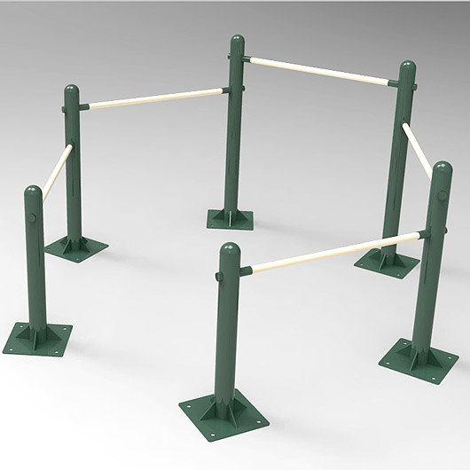

Multi Bars – All ages groups can perform a variety of stretching exercises, as well as assisted push-ups and pull-ups

## Funded in part by the government of canada’s new horizons for seniors program

## What Else Should I Know?

## You are using the equipment at your own risk.

## If you would like personal assistance to learn the full use of this equipment please contact Parks and Recreation at the Office in Norval Centre to be paired with a Volunteer Mentor

Phone (250) 546-9456

or

Email: [armstrong@icesports.com](mailto:armstrong@icesports.com)

A partnership between Armstrong Spallumcheen Parks and Recreation Commission and the City of Armstrong Age Friendly Community Committee

# Memorial Park – Age Friendly Outdoor Exercise Equipment

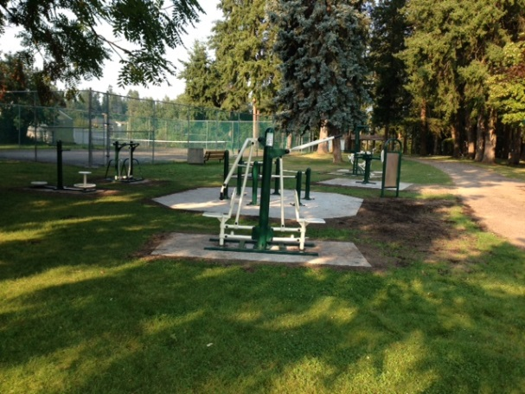

**For your personal safety**  - Please note that the equipment with moving parts is intended for use by adults, which can mean anyone age 14 and over who has a minimum height of five feet and minimum body weight of 100 lbs.

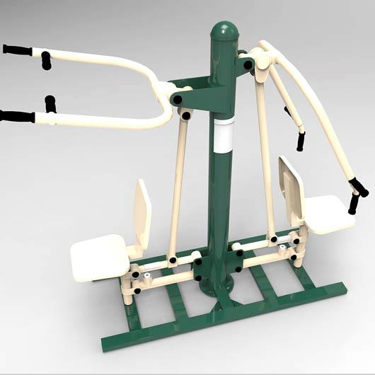

**Combo Press and Pull will increase strength in your**  Shoulders, Chest, Triceps, Biceps, Core, as you perform Lat Pulls and, Chest Presses. Start with 10 repetitions on each and build your stamina.

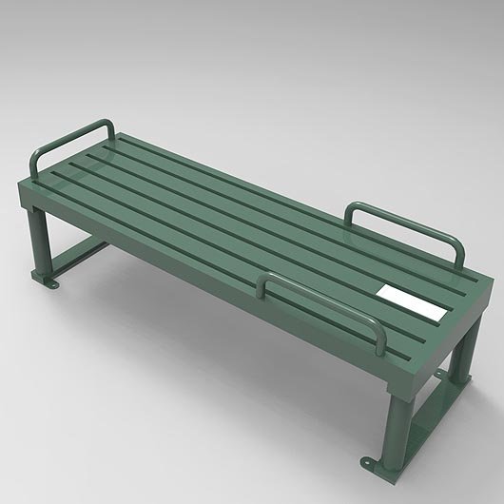

**Sit Up Bench** provides a multi-use platform for performing sit-ups, leg lifts, push-ups, assisted dips and stretching.

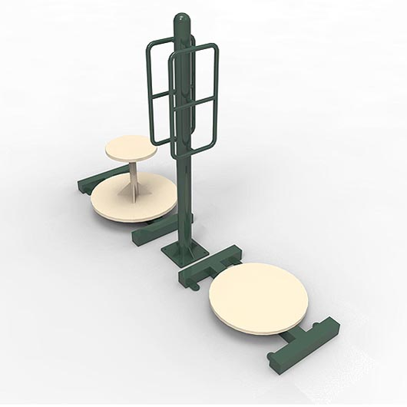

**Two Person Rotator.** Sit on one side – stand on the other. Using hand grips, keep upper body still and rotate from the waist.This product improves back and hip flexibility. Use it to stretch your obliques and exercise your abdominals.

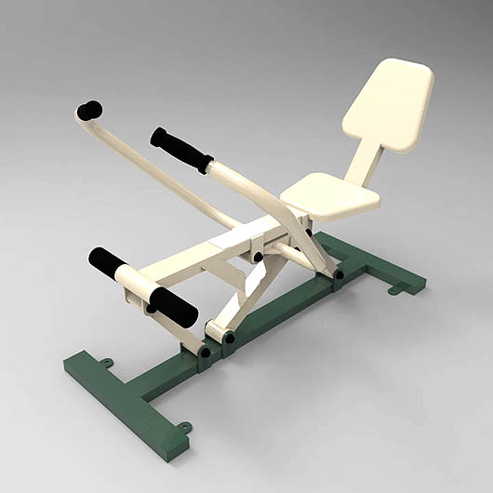 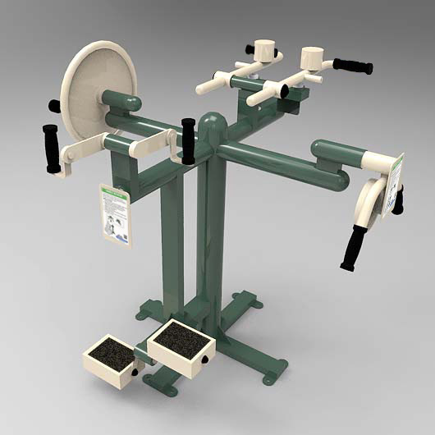

Accessible Multi-gym - A four station fitness unit designed to provide exercise to wheelchair or other mobility device users. Four stations include Shoulder Wheel, Hand Bike and Foot Bike, Rotator and Shoulder Press.

**Rowing Machine** Using a fluid motion - a portion of your body weight provides resistance and develops strength in your back, shoulders and biceps. It provides a great cardio workout as well.

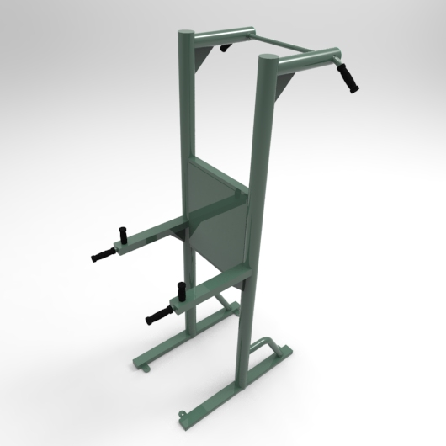

Company Name

Street Address

Address 2

City, ST ZIP Code

Phone (555)555-0125

Fax (555)555-0145

Web site address

**Pull Up-Dip Station** – Perform pull-ups, dips, leg lifts, as well as stretching exercises. Will improve upper body and core strength and flexibility.